**Simplified ERD:**

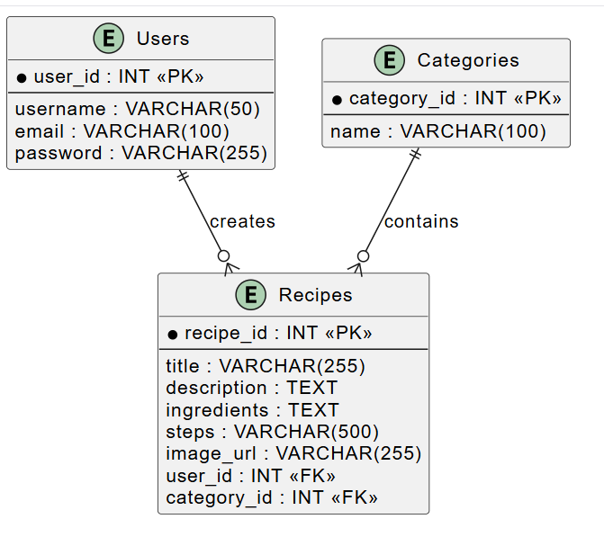

**We first focus on above three entities (database table). Once we able to achieve the basic structure, we can gradually upgrade to our project.**

**Hope the following description will be helpful for better understanding of above provided ERD.**

**Entities & Attributes:**

1. **Users** (user_id as Primary Key)
   * Stores user details like username, email, and password.
   * A user **can create multiple recipes**.
2. **Recipes** (recipe_id as Primary Key)
   * Stores recipe details (title, description, ingredients, steps, image_url).
   * **Foreign Keys**:
     + user_id: Links to **Users** (who created the recipe).
     + category_id: Links to **Categories** (for classification).
3. **Categories** (category_id as Primary Key)
   * Stores recipe categories (e.g., Vegetarian, Desserts).
   * A **category can have multiple recipes**, but each recipe belongs to **only one category**.

**Relationships:**

* **Users** ||--o{ **Recipes** → One **User** can create **many Recipes**.
* **Categories** ||--o{ **Recipes** → One **Category** contains **many Recipes**.